**Experiment No. 11**

### Name: Rebecca Dias Roll No.: 19 Class: BE CMPN A PID: 182027

**Aim:** To implement Image smoothing/ Image sharpening.

**Theory:**

* What is Image smoothing/ Image sharpening?
  + **Image smoothing**:Smoothing is used to reduce noise or to produce a less pixelated image. Most smoothing methods are based on low-pass filters, but you can also smooth an image using an average or median value of a group of pixels (a kernel) that moves through the image.
  + **Image sharpening**:Sharpening is a technique for increasing the apparent sharpness of an image. Once an image is captured, Photoshop can’t magically any more details: the actual resolution remains fixed. Yes, you can increase the file’s size but the algorithms any image editor uses to do so will decrease the sharpness of the details. In other words, the only way to increase apparent sharpness is by increasing acutance. If you want your image to look sharper, you need to add edge contrast.
* Importance of Image smoothing/ Image sharpening
  + Digital images contain various types of noises which reduce the quality of images. Noises can be removed by various enhancement techniques. Image smoothing is a key technology of image enhancement, which can remove noise in images.
  + There are three main reasons to sharpen your image: to overcome blurring introduced by camera equipment, to draw attention to certain areas and to increase legibility.
* Explain Image sharpening using numerical

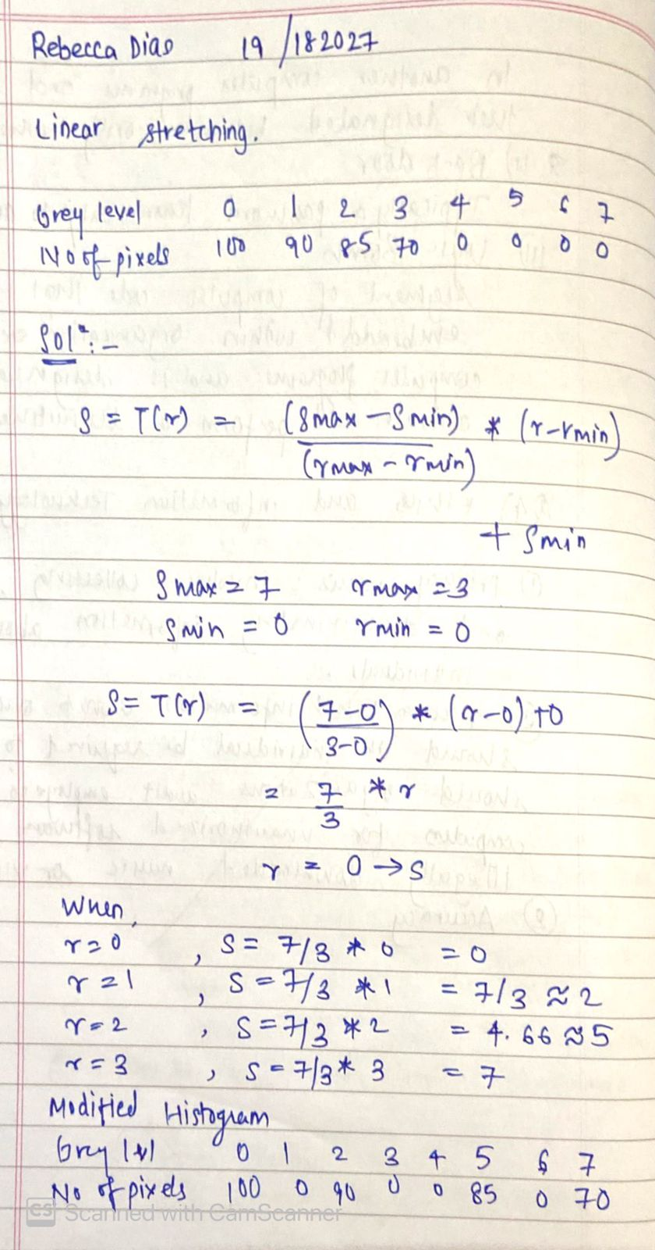

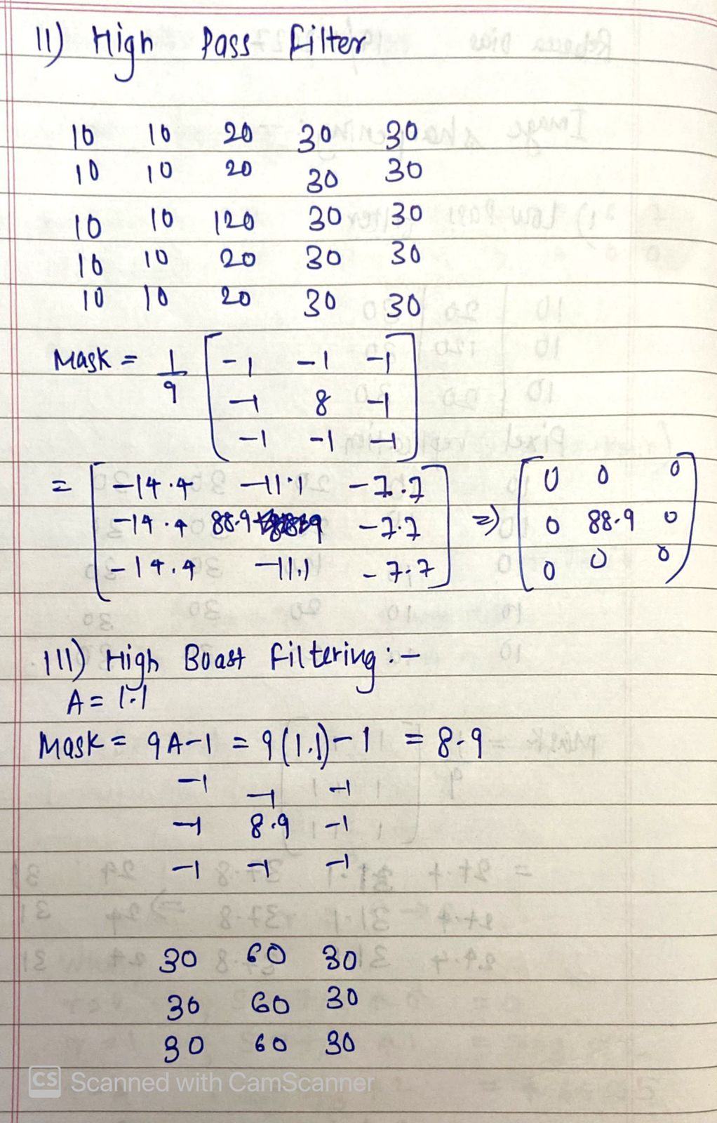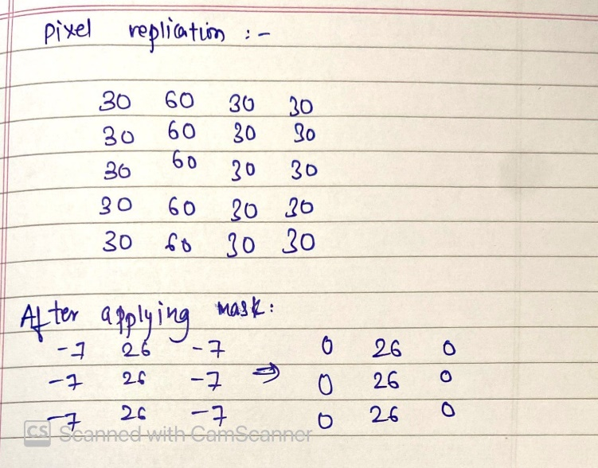

**Implementation:**

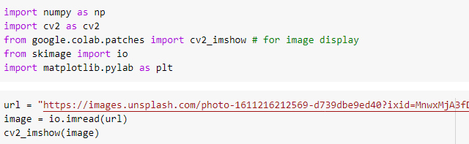



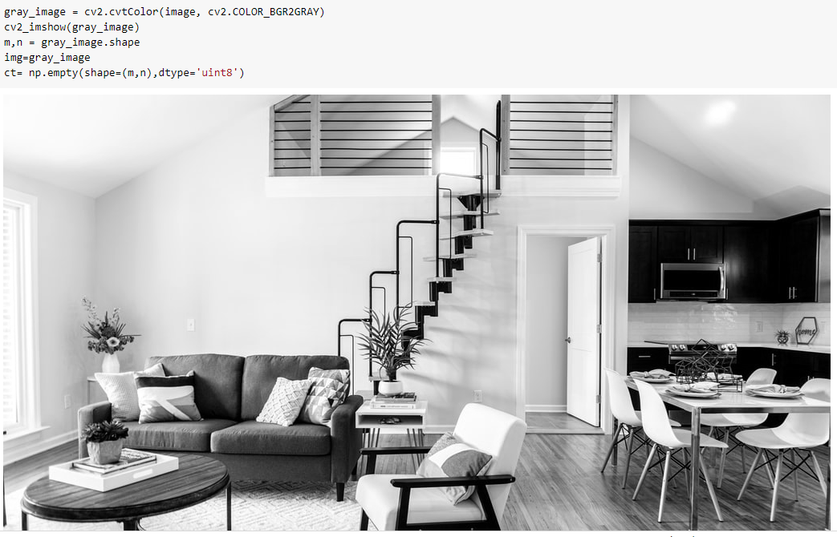

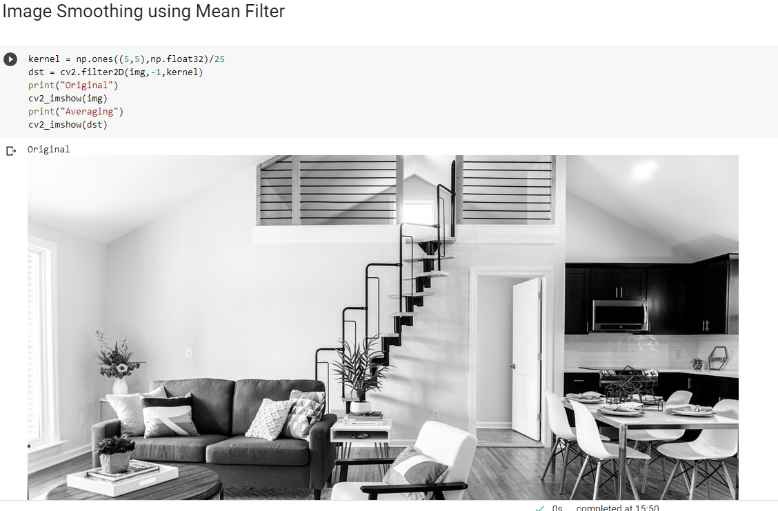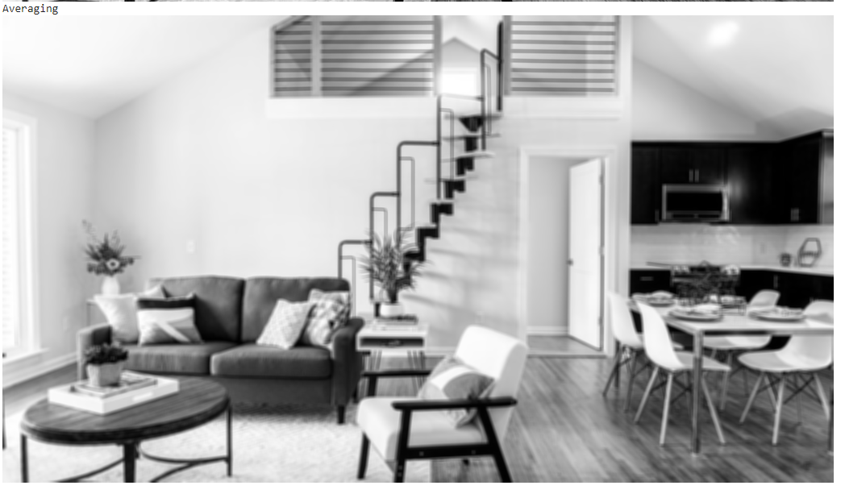

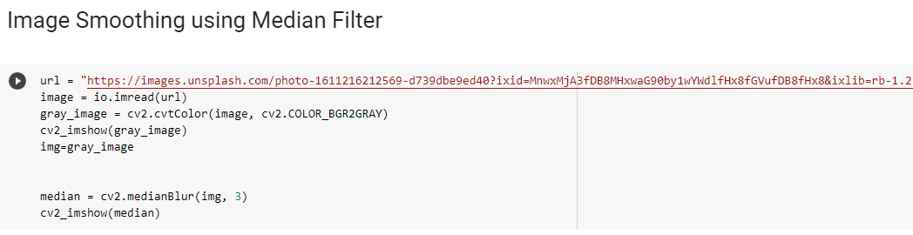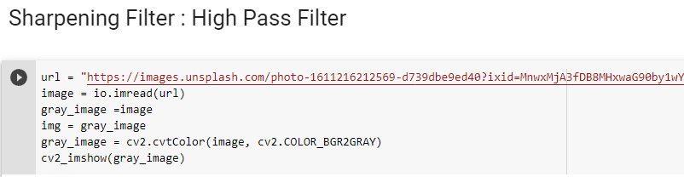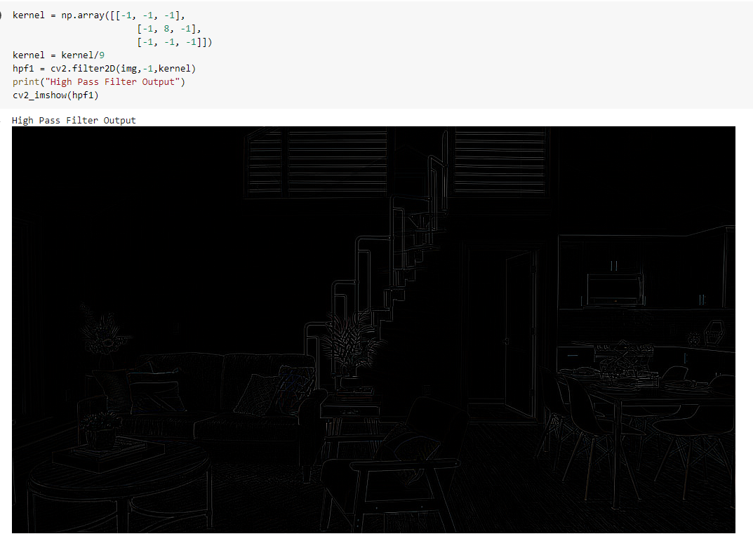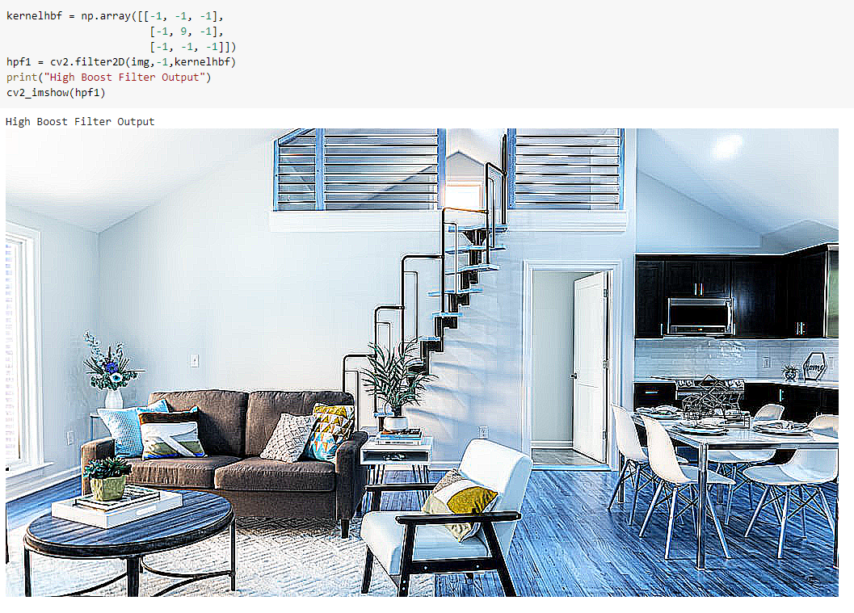

**Conclusion:** In this Experiment we learned about Image smoothing and Image sharpening. Smoothing is used to reduce noise or to produce a less pixelated image.Sharpening is a technique for increasing the apparent sharpness of an image. We also implemented the same in python and successfully got the output.